Notes for my Zoom meeting on August 3 and 4
"The first impulse in every healthy mind, upon hearing a good thing, is to pass it on to others." Glover
What I am going to give you is a “good thing”, so I am passing it on to you.
Three steps of growth:
1. As children we are dependent upon our parents.
2. As parents we try to teach our children to be independent.
3. As adults we should be interdependent people, that is helping others.
Give a man a fish and he will eat for a day.
Teach a man how to fish and he will eat for a lifetime.
SOME HISTORY, BEGINNING JULY 1, 1980.
Georg Friedrich Hege said: The only thing we learn from history is that we learn nothing from history.
OHP
Retention Chart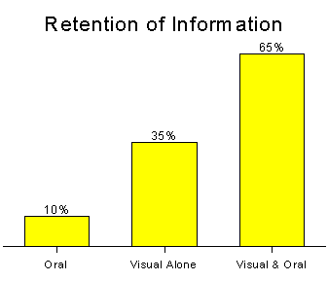

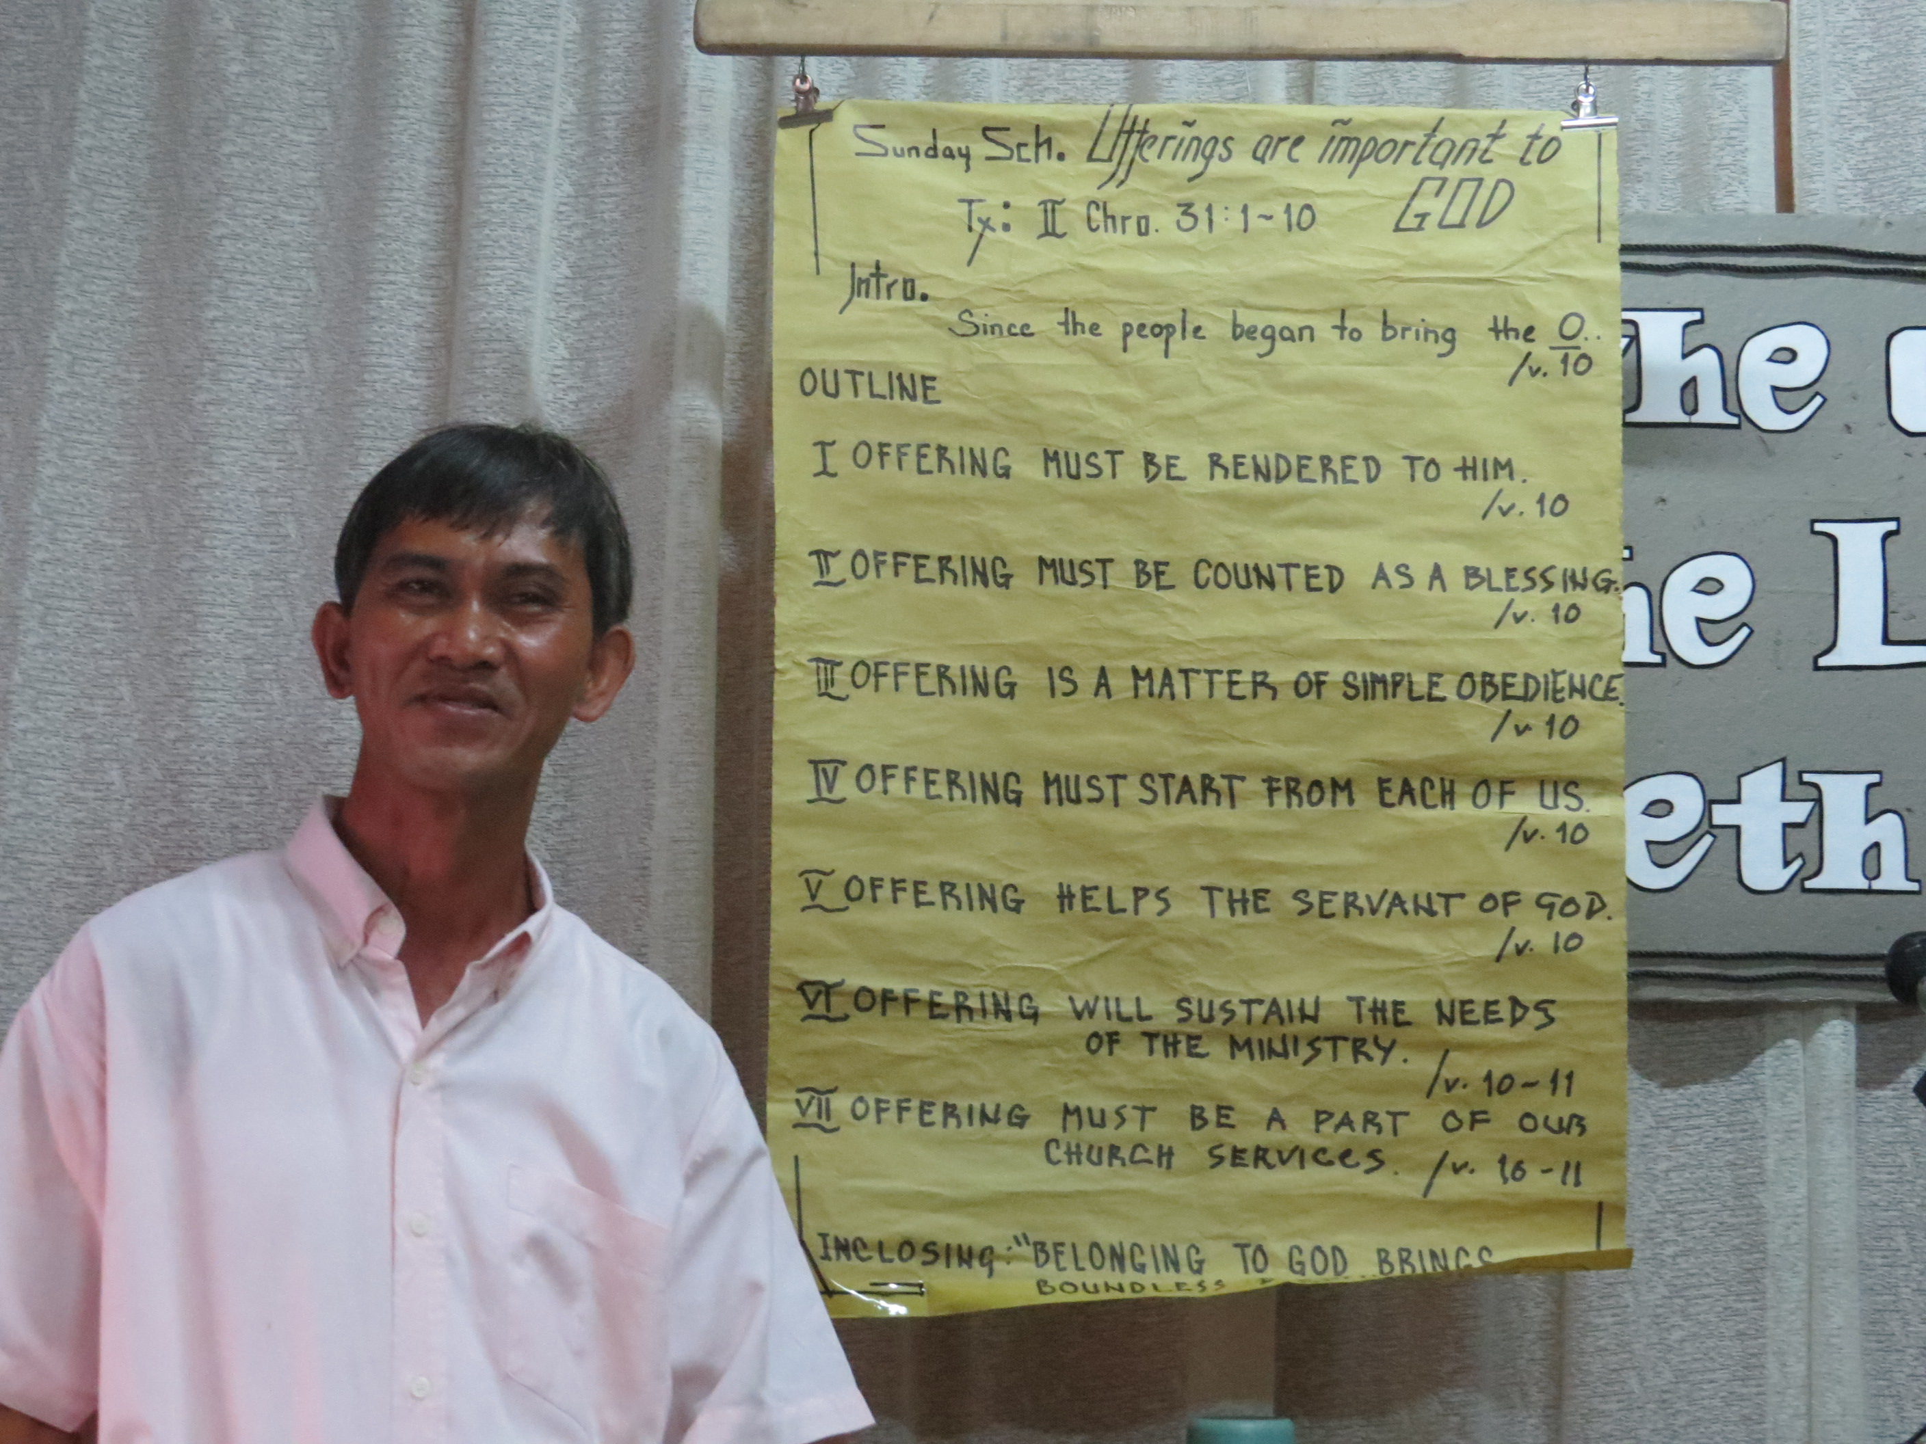
Give out page Bible page numbers caller
Copy of message for every person given out as people leave the church
SOL – Certificate – Bible – Tuesday follow-up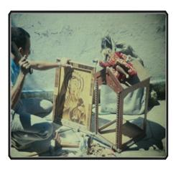
Bible Institutes
BI Mistakes I made
Send out best people
Bible women – Use Flor
Preach on hell – Picture
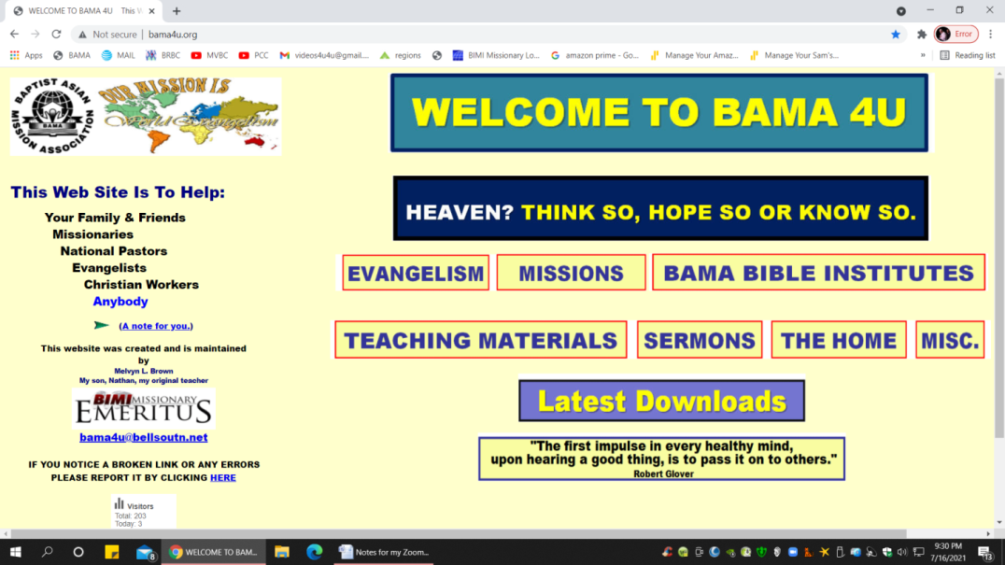
Money & Faith –Francis Dixon
Who does God use?
Repeat visitation visits
Soul winning – make a video, picture book
Teach soul winning
Discipleship
Family
Why we use the KJB
Daily reports

